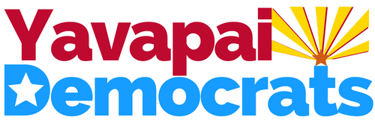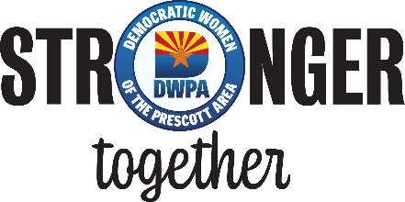

When the going gets tough, the Dems get stronger—together  Supplemental Nutrition Assistance Program (SNAP) benefits are set to be suspended November 1, if the current federal government shutdown continues.  The pause in SNAP benefits will leave many families in our communities struggling to put food on the table. Even if the court orders the administration to use reserves to partially fund food assistance in November, local food banks are already feeling the strain and are asking for help. The YavDems have teamed with DWPA to implement a two-pronged response: | 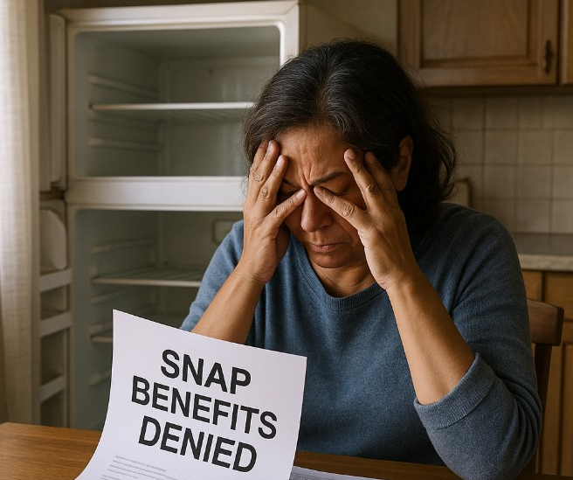

1 | Instead of collecting food, the two organizations will work to raise funds for the Prescott Community Cupboard. The Cupboard serves both Prescott and surrounding rural communities, where food insecurity is even higher, through its mobile food pantry. Every donated dollar enables the food bank to purchase large quantities of food at wholesale prices. For example, $1 can provide up to 4 meals by buying in bulk, $25 can feed a family for an entire week.
For YavDems, this means 100% of the proceeds from the upcoming Monthly General Meetings on November 20th and December 18^{th .} will be donated to the Community Cupboard. Please contribute what you can by:
- Buying more raffle tickets than usual
- Dropping cash or a check in a donation jar
- Donating directly to the Community Cupboard at: https://thecommunitycupboard.org/donate.html
No amount is too small — every dollar truly makes a difference!

Additionally, the Yavapai County Democrats and DWPA are coordinating with Granite Peak Unitarian Universalist Congregation to collect everyday essentials for donation to the GPUUC Food Pantry. These essentials include diapers, feminine hygiene products, laundry detergent pods or sheets, dish detergent, soaps, deodorant, toilet paper, facial tissue, napkins, paper towels, toothpaste, and toothbrushes, etc. | 2
Donations can be dropped off at the Yavapai County Democratic Party Headquarters (lower level, 101 W. Goodwin St.) Monday through Friday, 11am–3pm. Another drop-off point is DWPA’s Liberal Libations on November 5 at Augie’s from 4–6pm. A collection truck for everyday essentials will be available outside the Center on Rosser at the YavDems General Meeting and Potluck on November 20 (and on the prior day, at the Centennial Center during the November 19thDWPA Luncheon).

According to zipdatamaps.com, as of July 2023, 21,415 Yavapai County residents received SNAP benefits, representing 10.1% of the population. The 2019-2023 American Community Survey estimates that, of those households, 34% had children under 18, and 51.8% had one or more people aged 60+. Together, the YavDems and DWPA can help ensure these individuals don’t go hungry during this difficult time.

